|  |  |
| --- | --- |
| SDA project report  Final project | Abstract  The testing documentation of websites (https://www.demoblaze.com/ and https://reqres.in/) was displayed in the report and included defects, test cases, testing kinds, and so on. Mamunur Islam  *Tester* |

**Contents**

**Headings Pages**

1. **Document propose 2**
2. **Testing section 2**
3. **Testing checklists 3**
4. **Detailed test cases 4**
5. **Founded issues/bugs 5**
6. **Improvements 6**
7. **Test design techniques 6**
8. **Used tools 6**
9. **Reflection 7**
10. **Document purpose**

In this document, the tester wants to test the specified websites <https://www.demoblaze.com/> and <https://reqres.in/> . To find out some key aspects which are:

* Defining testing area
* Functionality section testing
* Forming test cases

And so on.

1. **Testing section**

Using browser, [Demoblaze](https://www.demoblaze.com/), it is recommended to land to specified website. And it is shown that in main menu there are some section which is illustrated the below picture while in a drawing it is specified the interest of tester to test the components.

Which are: Sign up, Log in, Contact, Cart and Home functionality

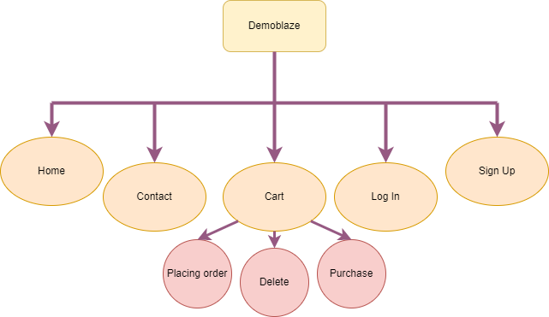

The API testing program Postman is used by the tester to send GET, POST, PUT, and DELETE requests to change the data while visiting the website https://reqres.in/. There is a needed paperwork for carrying out the operations on the mentioned website.

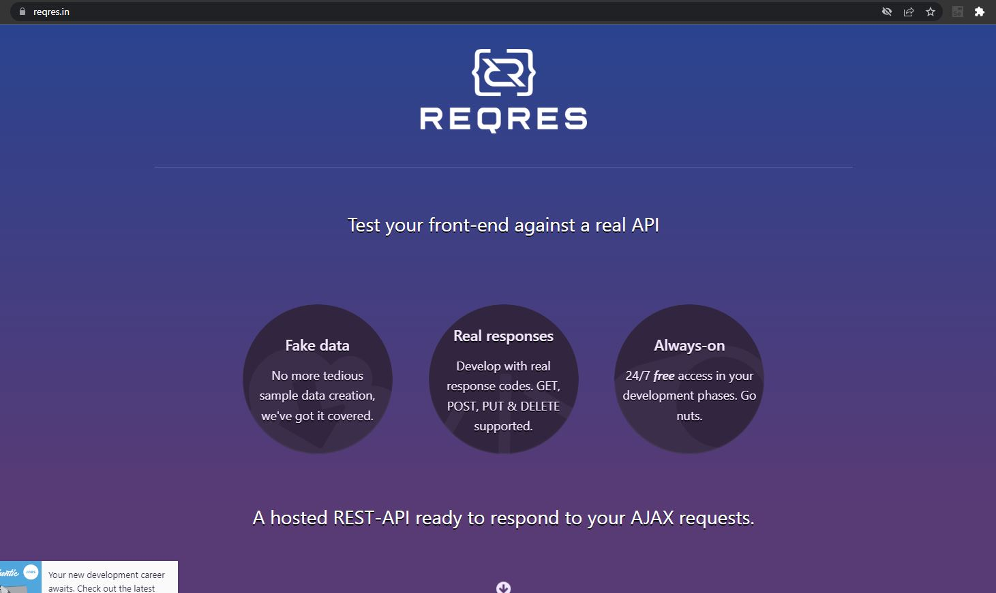

1. **Testing checklists**

The Demoblaze (<https://www.demoblaze.com/>) website is a commercial website. And the tester intends to do some feature testing alongside checking responsiveness of the website, which are specified below:

**Sign up:**

* Form correctness
* Registration

**Log in:**

* Adding new account
* Editing account

**Buying product and cart:**

* Using account trying product to add in cart
* Delete products(one and more than one ) from cart
* Purchasing product

**Log out:**

* Checking if log out options work correctly

**Contact:**

* Checking if message sent correctly

On the other hand the reqres (https://reqres.in/) website is completely build to test APIs. In this website the tester used the requests like

GET- to find the data and successful response

POST- to post some data and check changes accordingly

PUT- to update the data and

DELETE- to delete the data

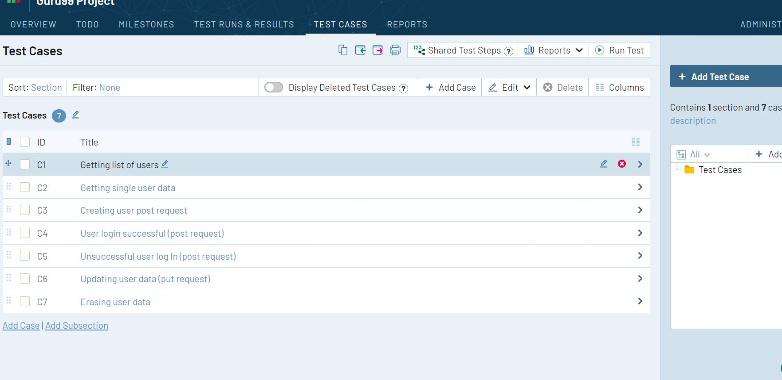

1. **Detailed test cases**

The detailed test case section will show how the test cases formed (a blend of high level and low level test cases) and below the screenshots are attached taken from related software like Jira and Testrail using Snipping tool.

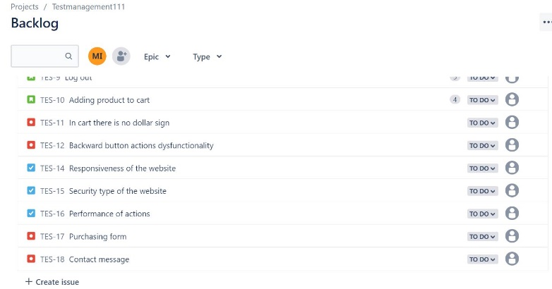**Demoblaze website’s cases and data:**

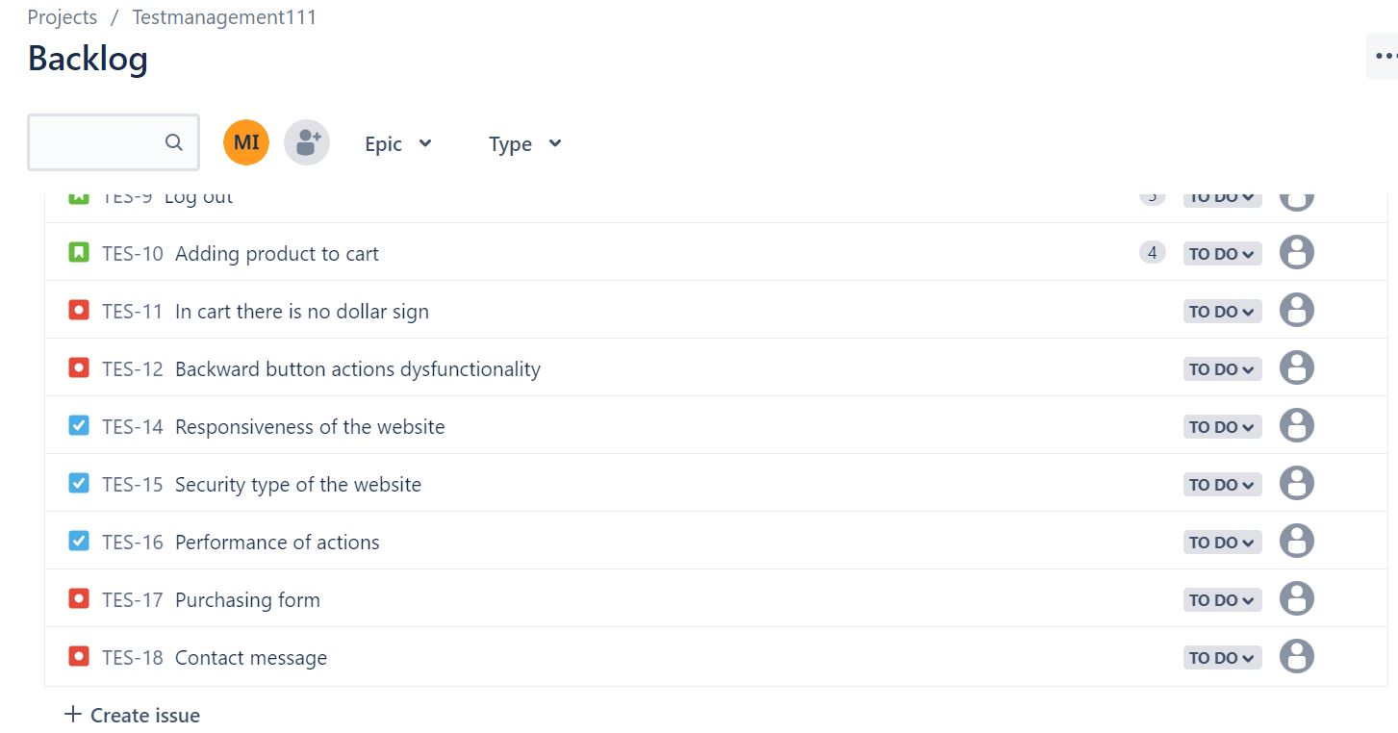

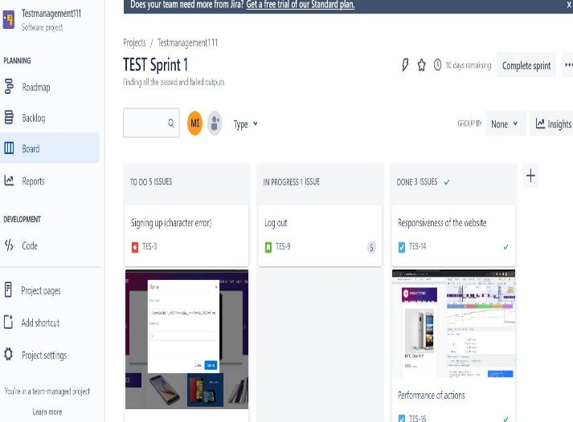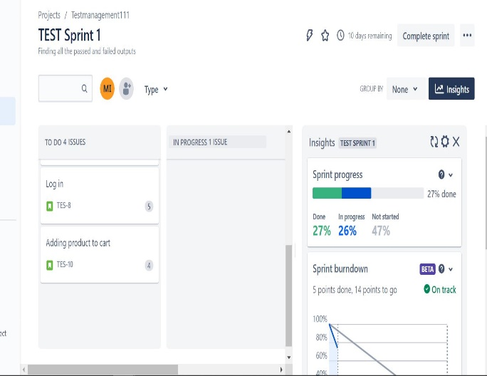

However, a failed operation and numerous passed requests and responses were discovered while testing APIs in [Reqres](https://reqres.in/). Pictures from the software TestRail are provided below.

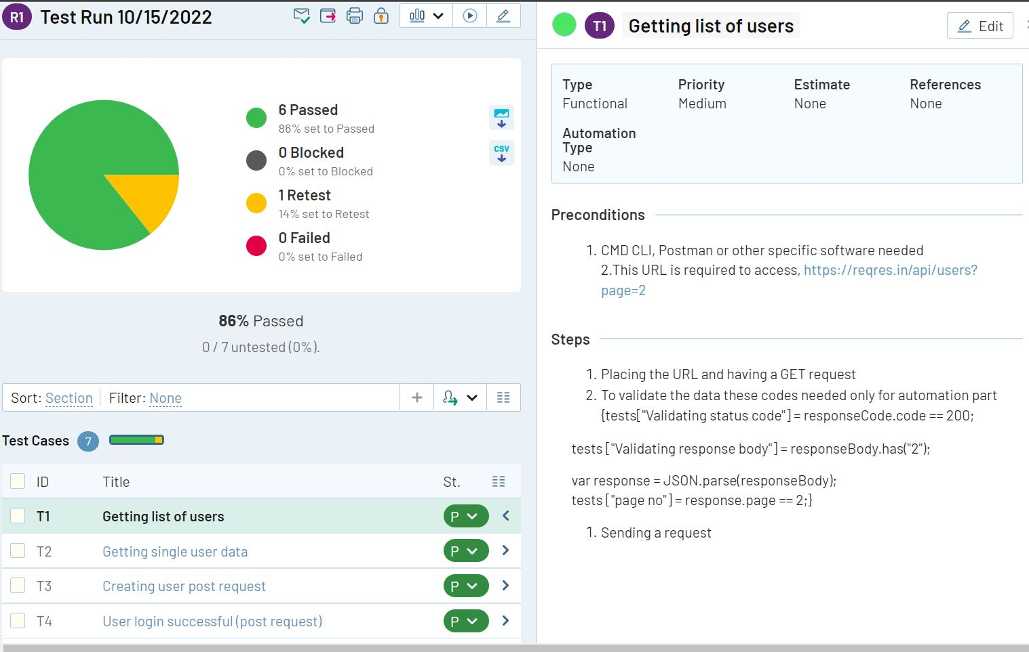

For more information [click](https://www.dropbox.com/sh/af7cga71xosmdfo/AAB4emvldD7FKe53skeVa_BQa?dl=0) here.

1. **Founded Issues/bugs:**

In [Demoblaze](https://www.demoblaze.com/), there are several bugs founded which are mostly functional bugs and most of them are crucial and immediately need to fix. However, there are no other types of bugs founded. Below one attachment added.

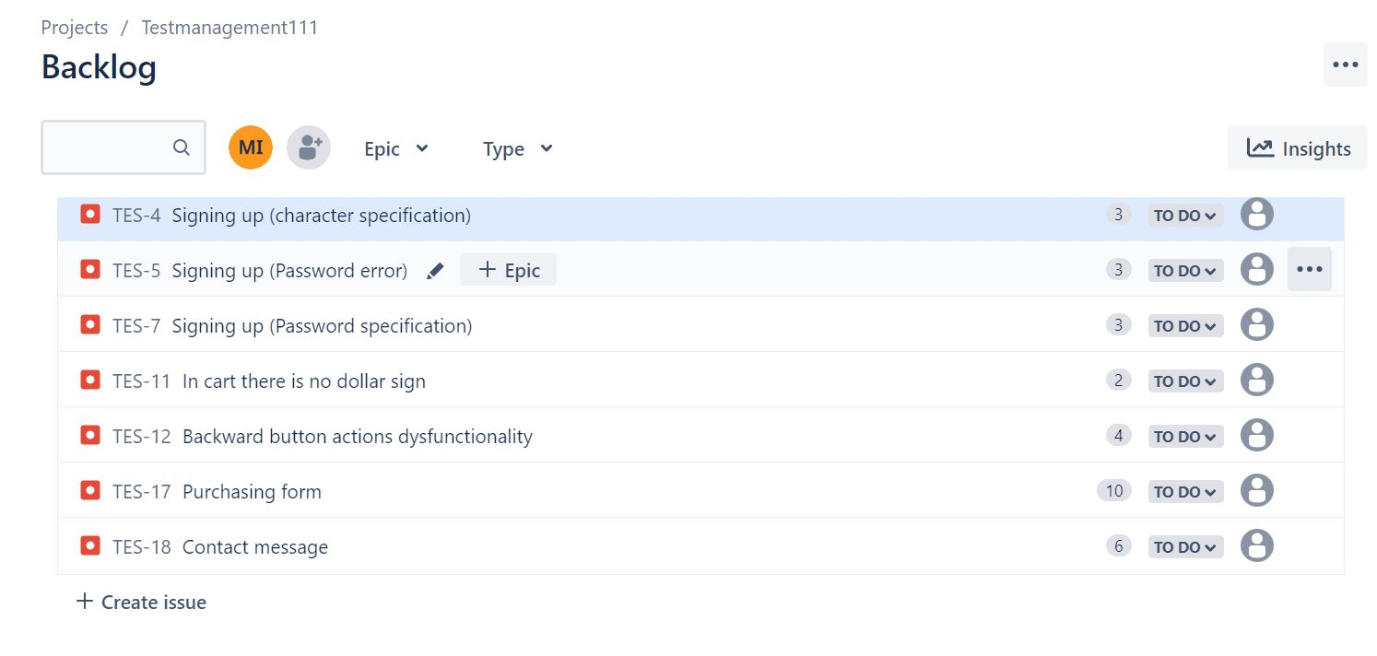

1. **Improvements:**

Even if the footer is static, the homepage's color and style were pleasant despite the evident issues. It would be beneficial if certain links were altered to point to alternative pages. Furthermore, the "About us" page only performs a page shutter and does not direct you to another one. The "Log In" and "Log Out" pages also have a very basic structure that does not appeal to users; in this situation, animations, buttons, and a password strength indication might be added. Additionally, the layout of the payment page may alter with some steps.

1. **Test design techniques:**

The test design technique used during the period:

* Black box
* Exploratory testing

1. **Used tools**

During the journey, the tester was using a few tools and have some documentation which mentoned above for more information(stored in cloud and anyone can see through the link).

The tools: Jira, Testrail, Snipping tool and Microsoft word.

Jira is used to create user stories, bugs tasks and so on for Demoblae web portal while Testrail is used to make Test cases test executions and so on. However, others were used to conducting screenshots and documents.

1. **Reflection:**

The experience I had while working is described below.

* It can be challenging to identify the objectives in the absence of requirements.
* Some instances confused if a thinking defect or an advancement
* Sign up and Sign In functionality and forms were not good enough due to poor coding and not to put boundary of values.